Social Engineering in Kali Linux.

<https://www.youtube.com/watch?v=4mzUMXx8tqE&list=PLofDtN0mMFtP4Pw3m2ndWbA7o1-7z-MS4&index=1>

Use ubuntu virtual macine and make this website. Make login.html in text editor and put ip addr of kali linux machine. Follow <https://www.youtube.com/watch?v=F8tUPeMl_DU&list=PLqfPEK2RTgCgJhjoDrmUYY7R0mzJzw9Mu&index=47>

I did this on my ubuntu but copy paste isnt working

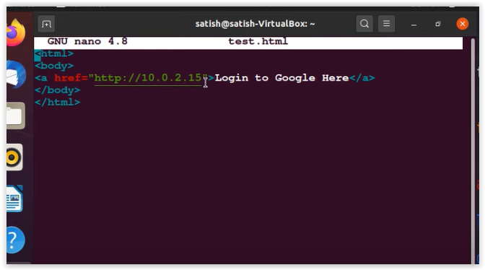

Now go to kali linux and open social engineering tools

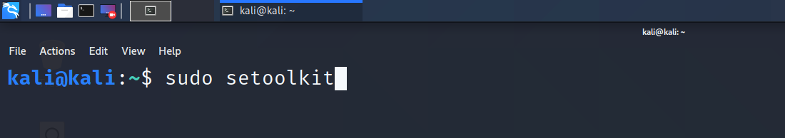

Follow selections

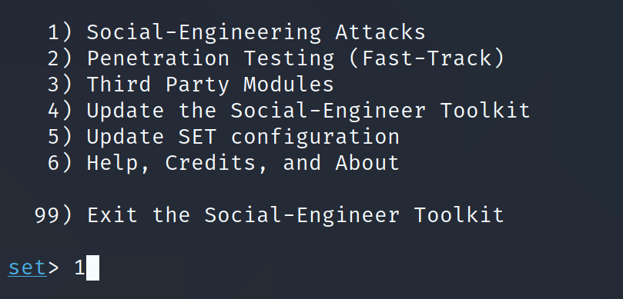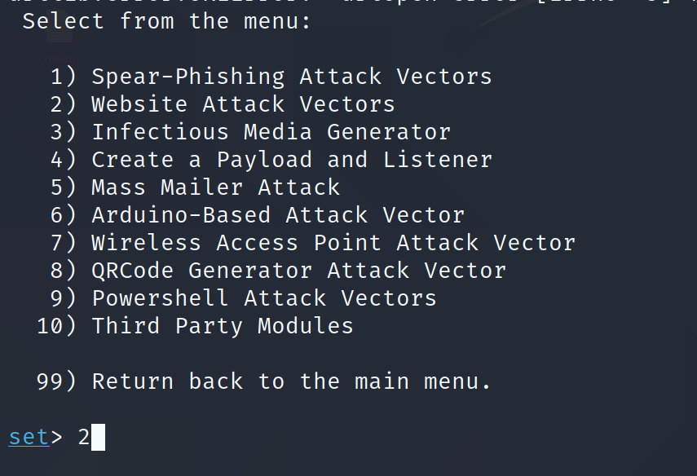

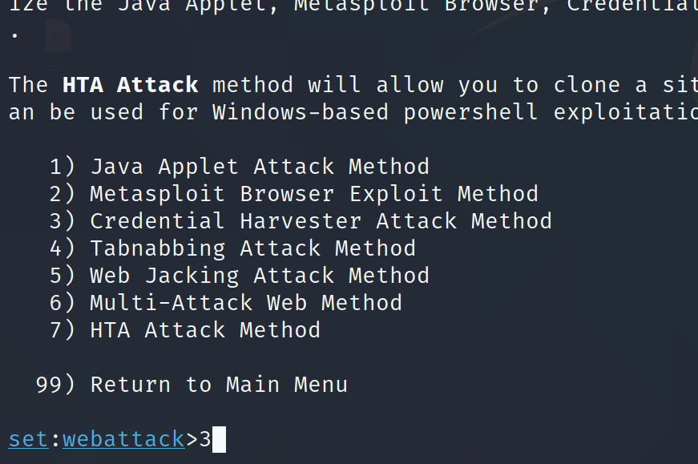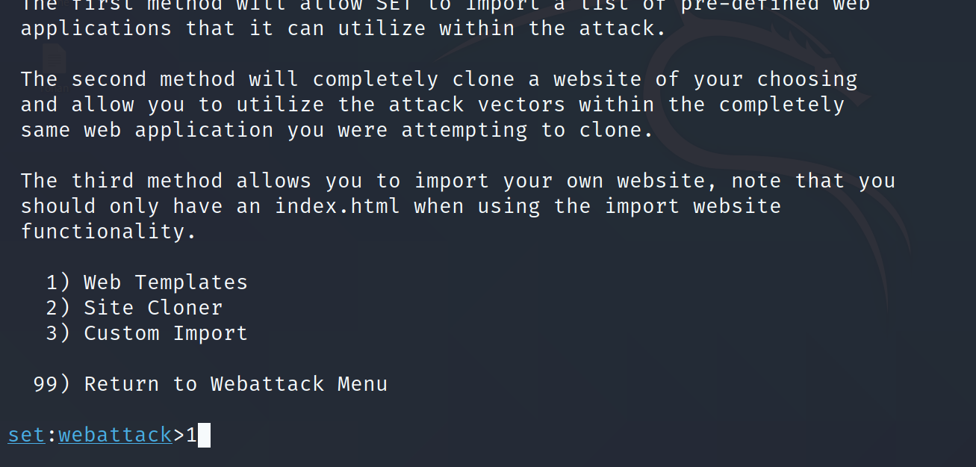

Fill ip address of listener (kali)

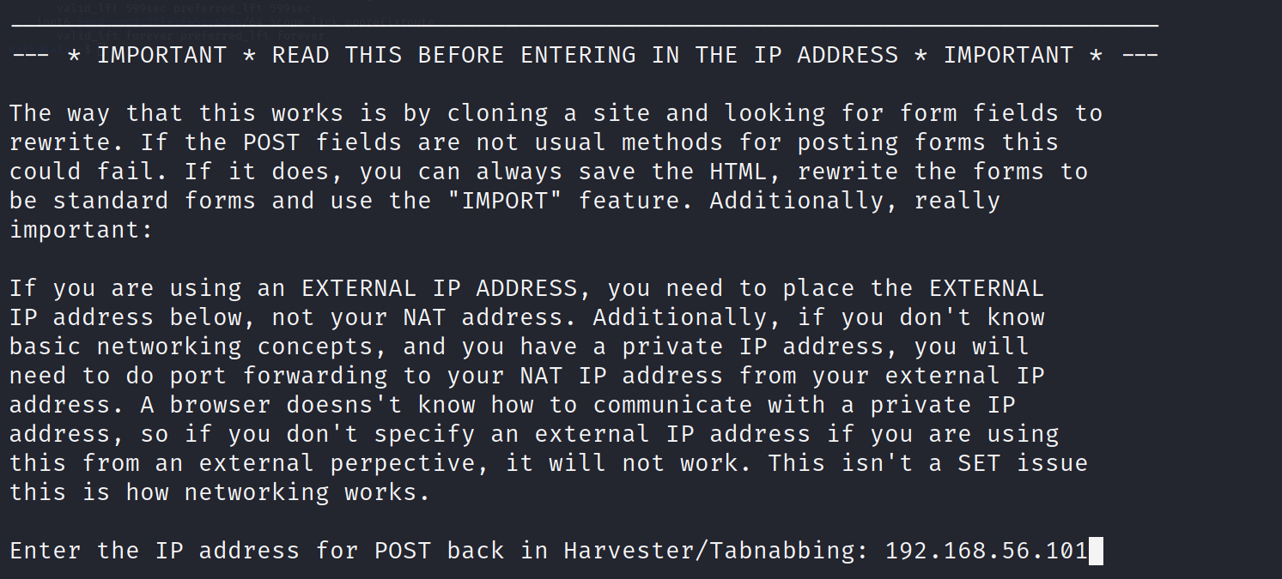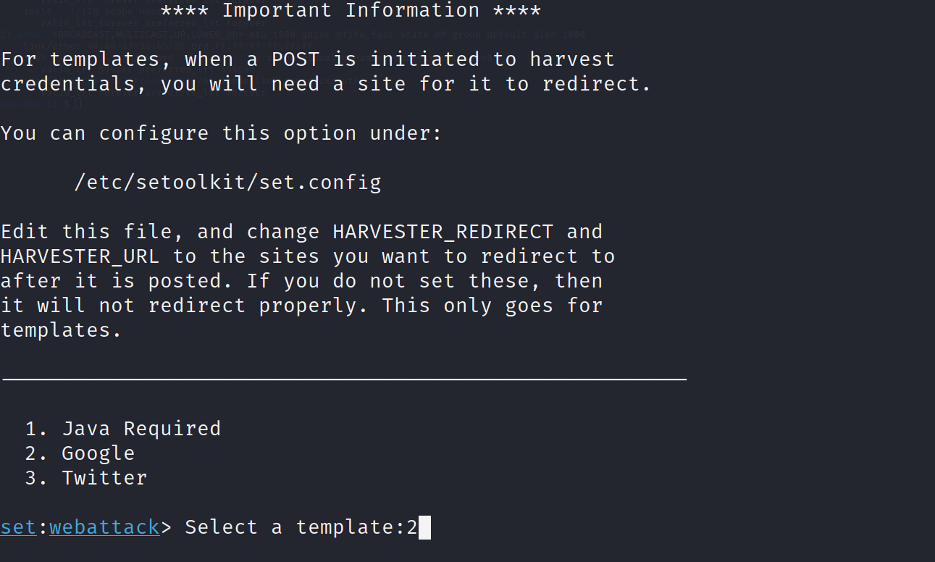

This clones a gmail login site and extracts username and passwords of unsuspecting users.

Open that html file in ubuntu.

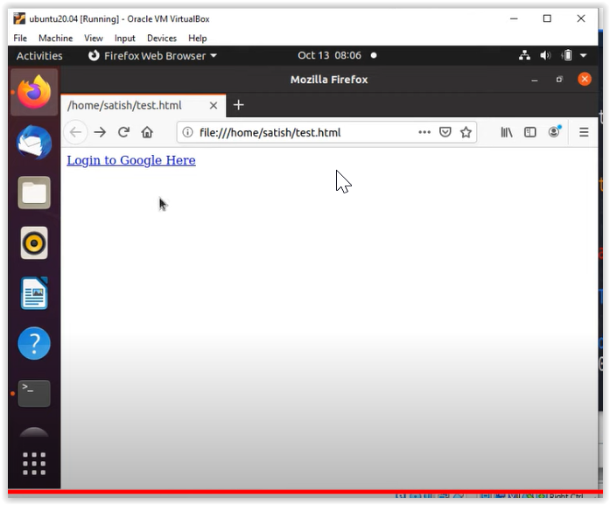

On clickink anchor link redirects to clone site

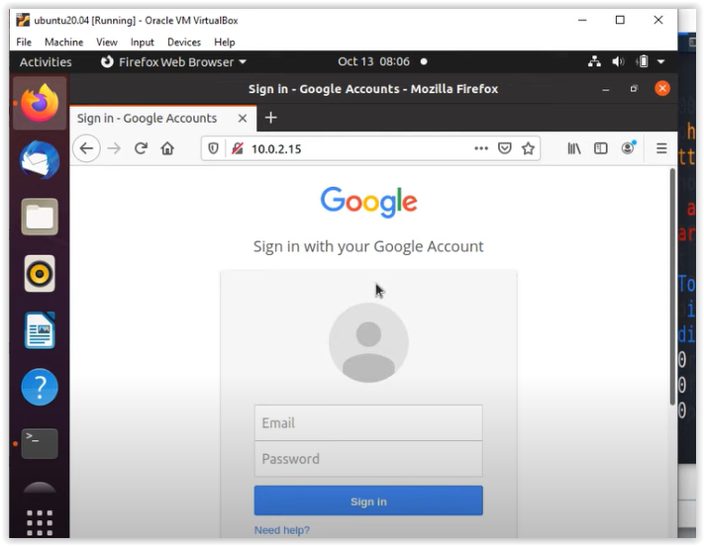

Fill in details.

Details are now visible in kali machine.

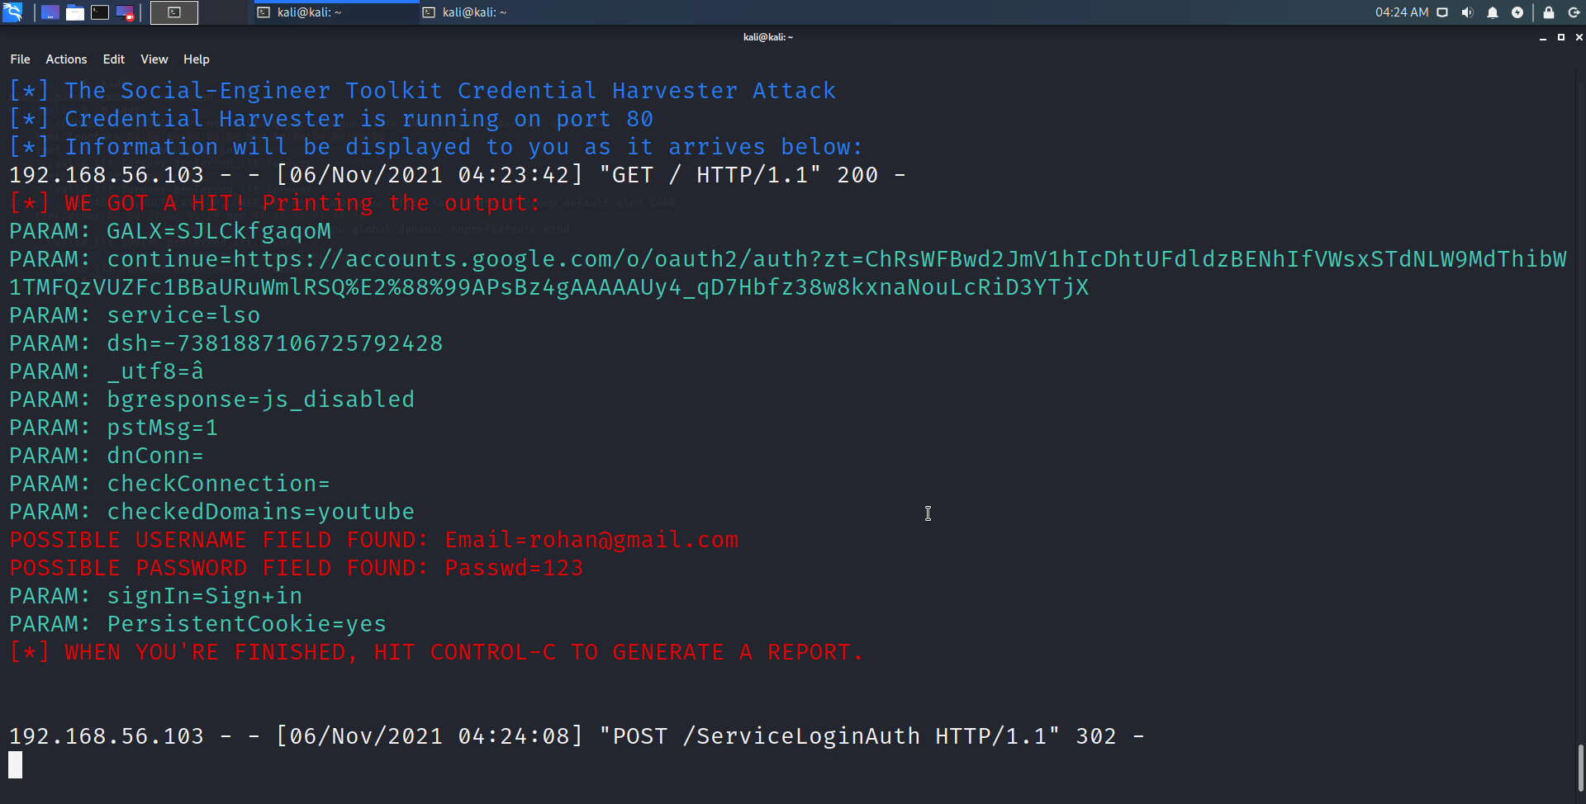

Now to build on this we will do phishing attack. Instead of opening this siye which has he url link(kali ip) to the malicious site, we will send this link by mail.

After doing the above steps, open new terminal, don’t close prev one where u get credentials.

Ip addr of kali

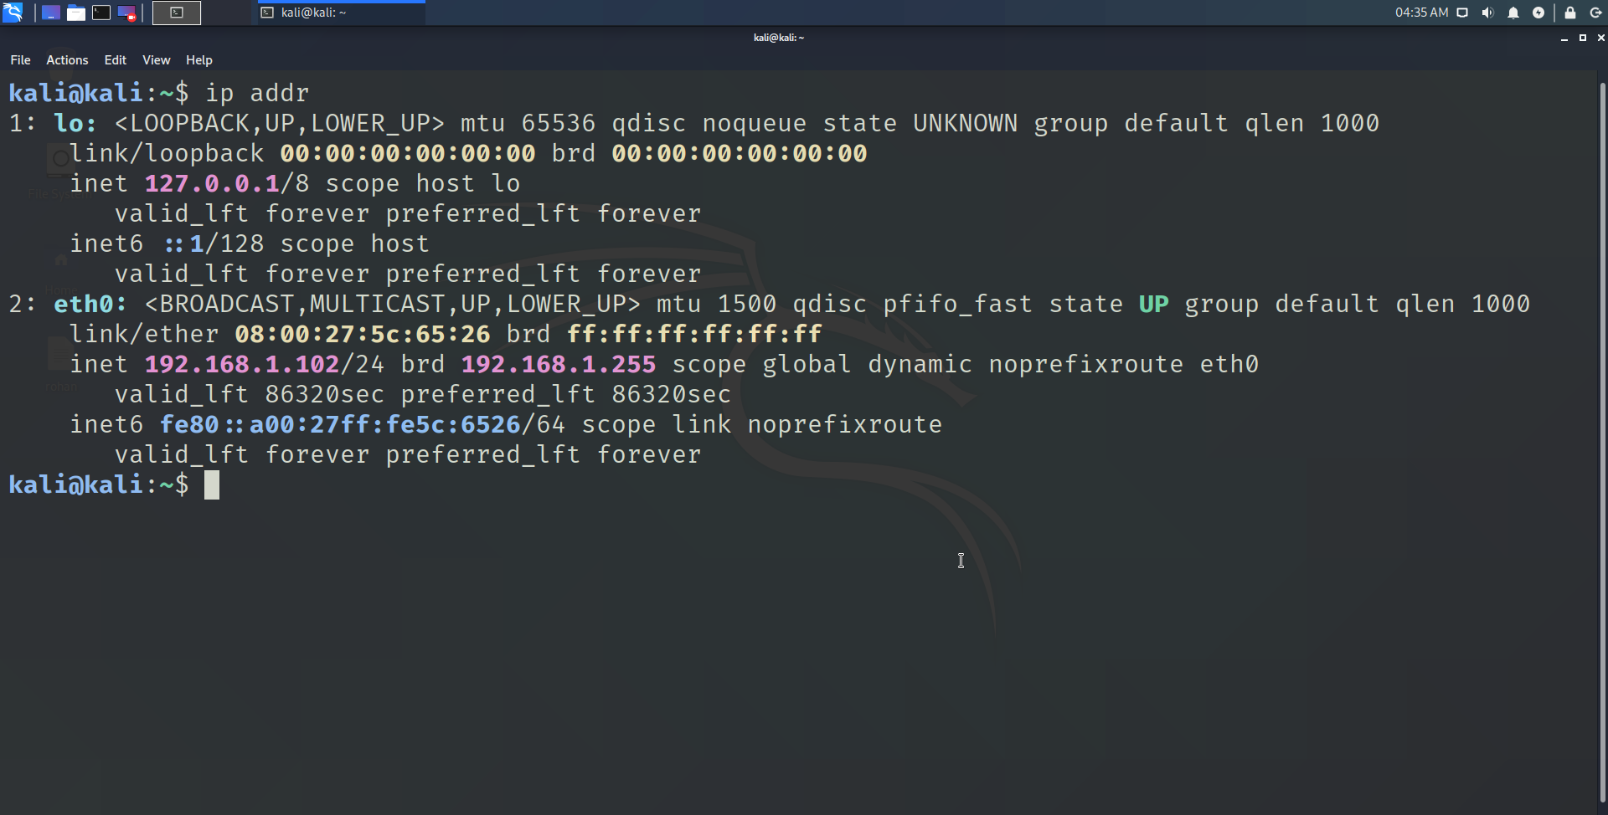

Open setoolkite and select social engineering and then mass mail attack

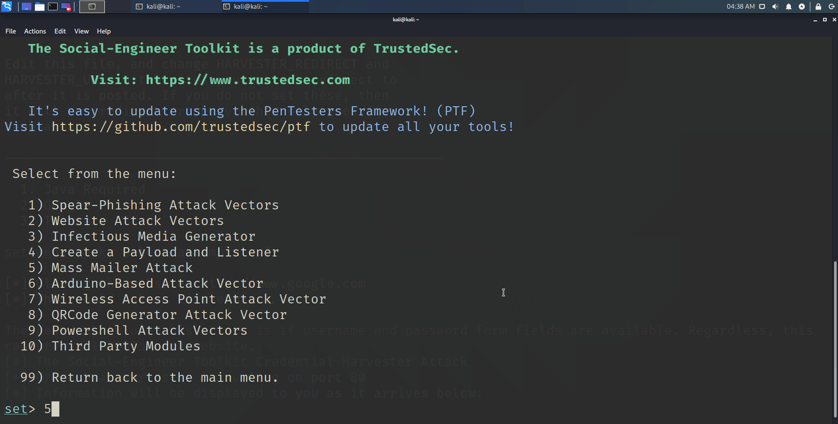

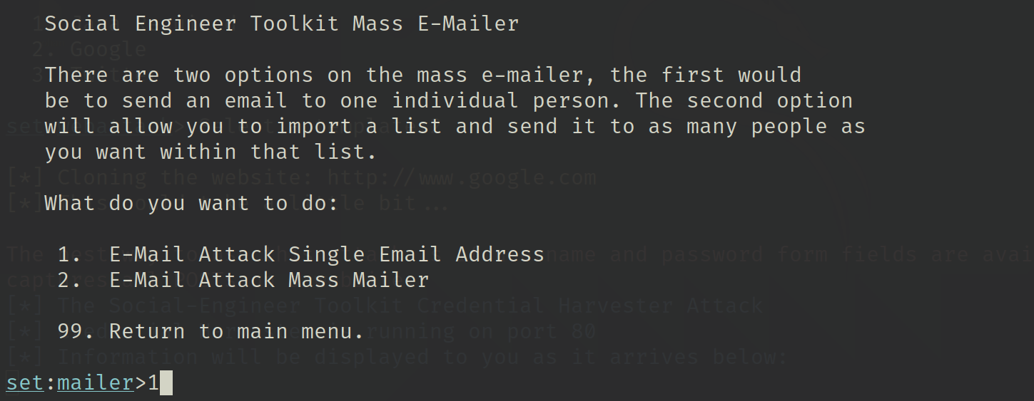

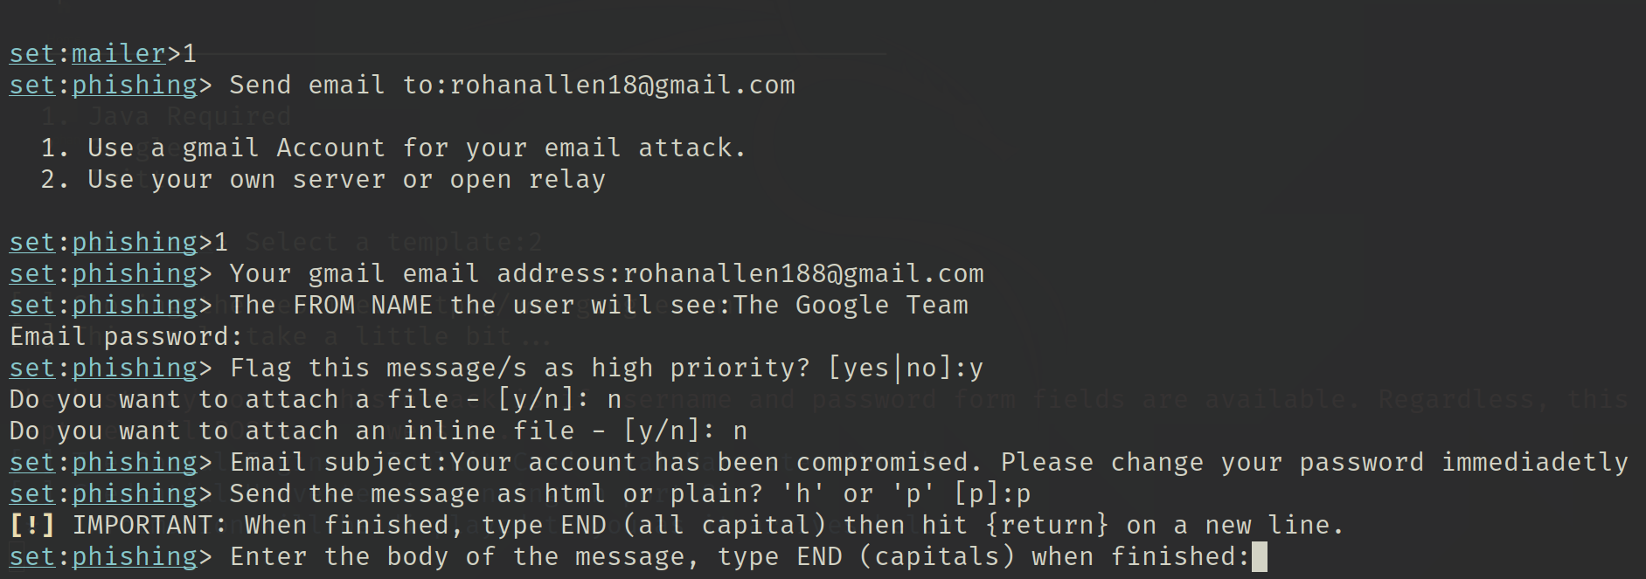

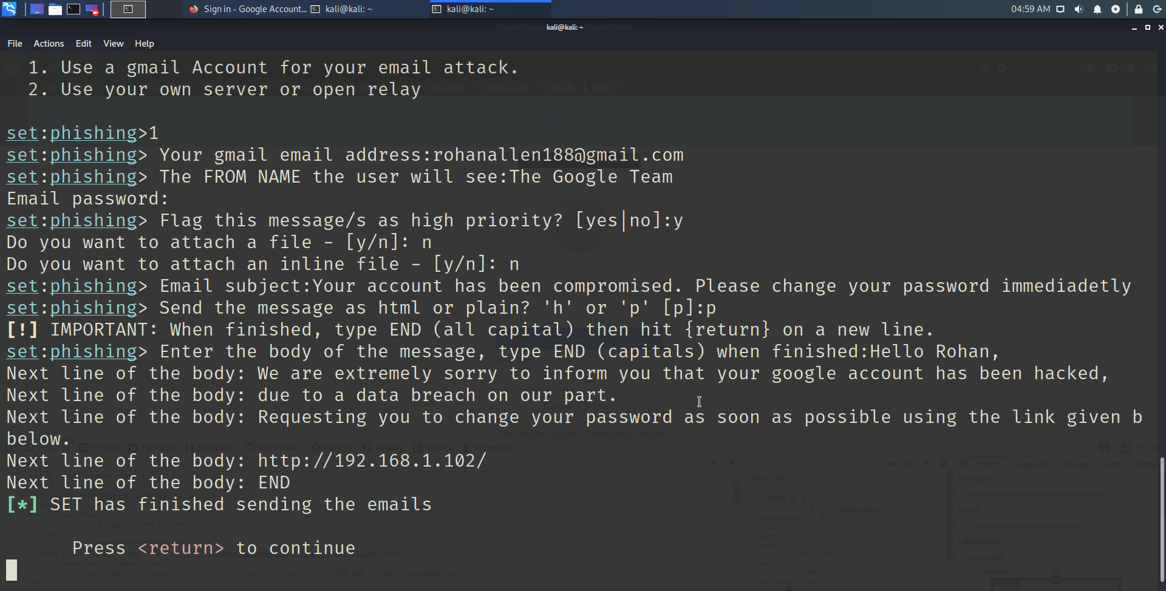

In this case mail was blocked, but if u go to ur mail settings and enable less secure app access, then the mail will be sent with the link.

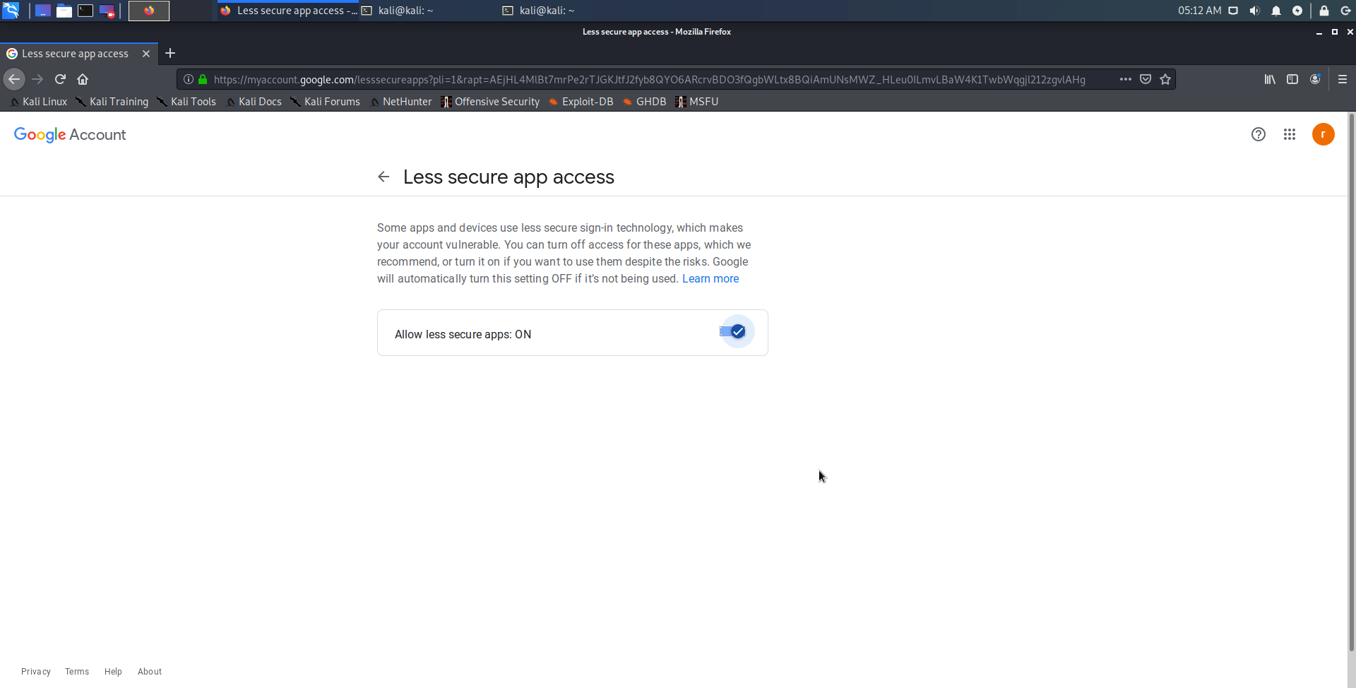

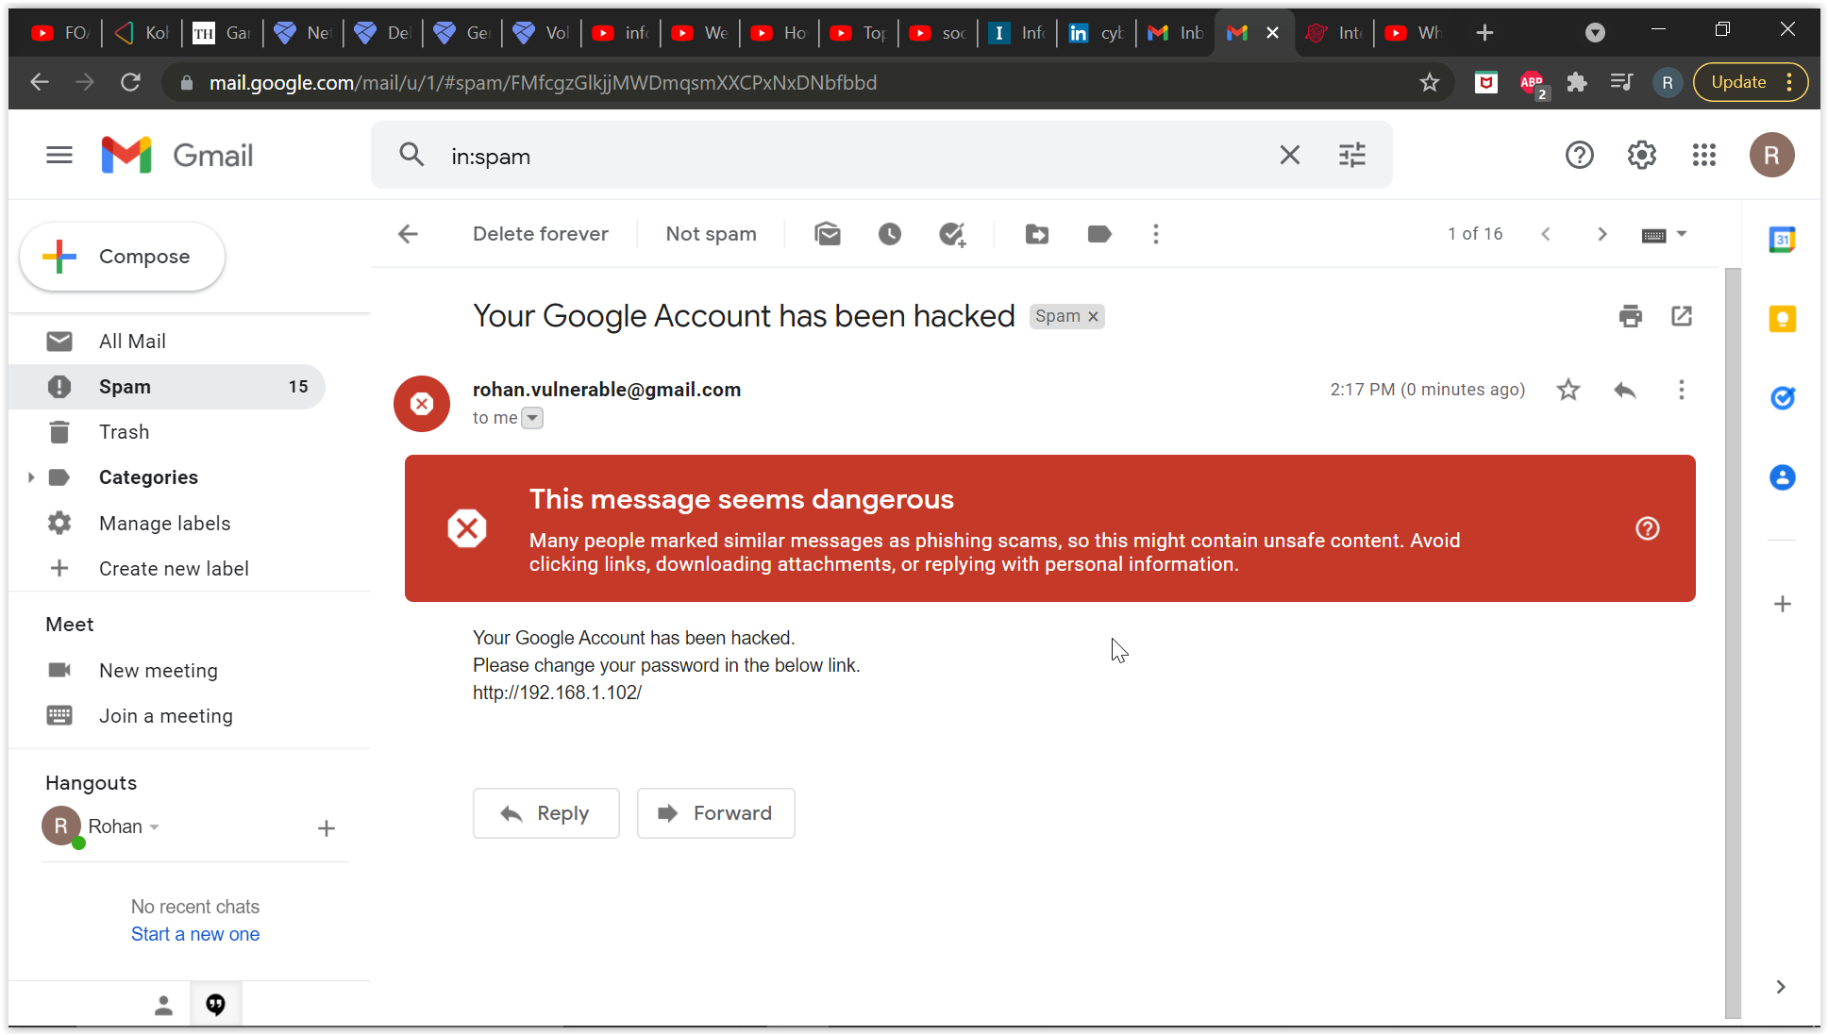

Open the link. And

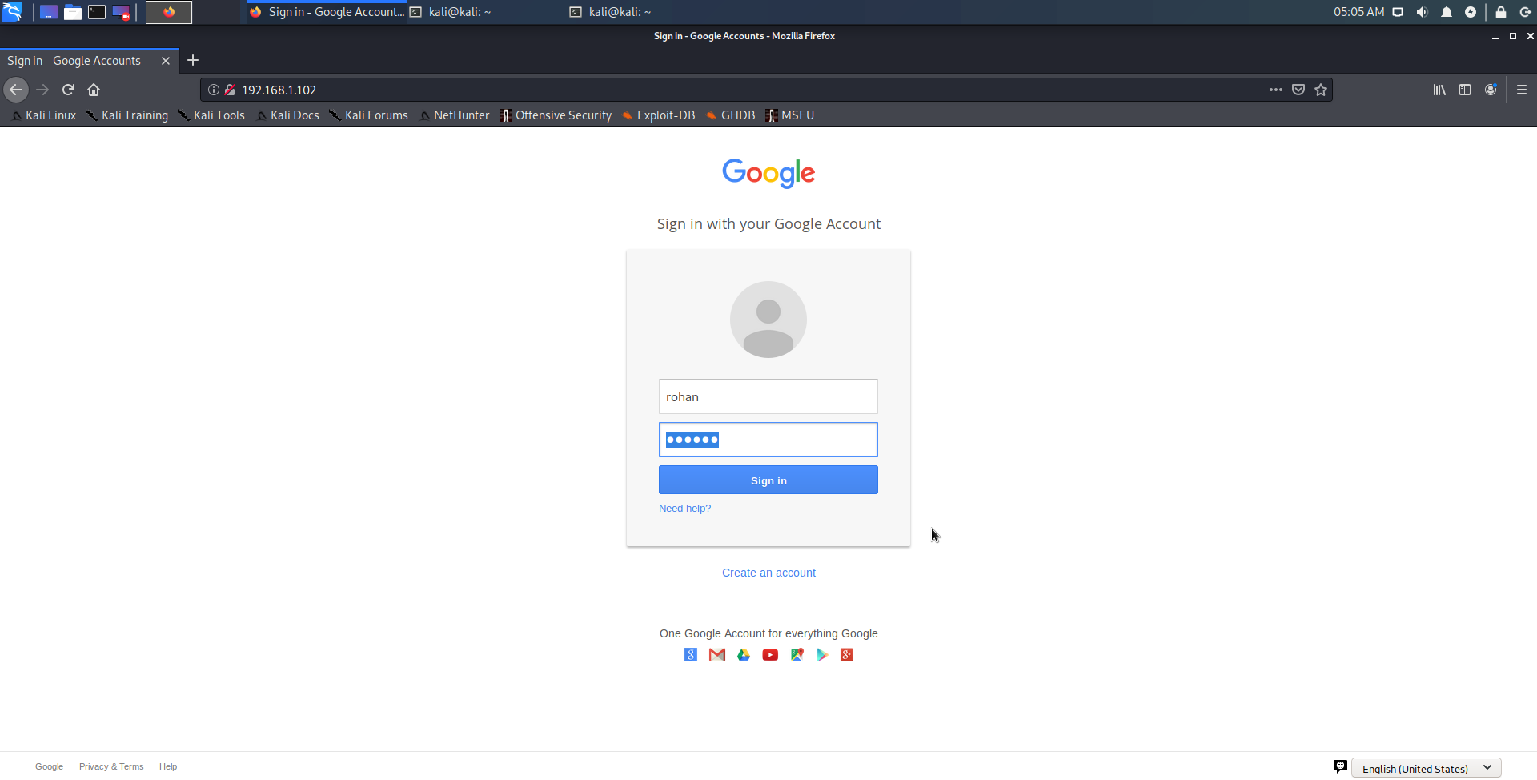

Credentials stolen

